**Udacity – Exploring the weather trend**

Exploring the weather trend between Sydney and global

1. **Objective:**

This project is to provide weather trend analysis between Sydney and the world using their annual average temperature from 1841 to 2013

1. **Methodology**

First, the following SQL code was used to extract the relevant data from Udacity, which returned 173 results

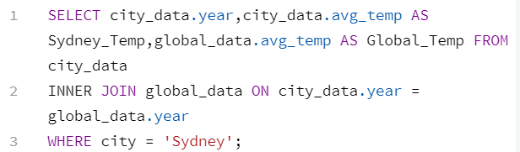

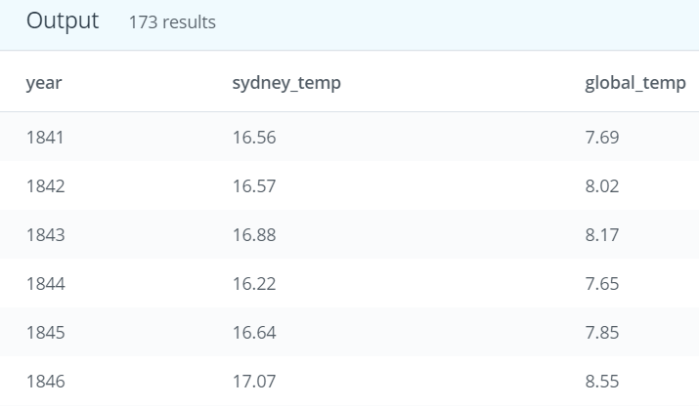

This set of data was then downloaded as the CSV file and opened with Excel. To smooth out the fluctuation between the years, a ten-year moving average calculation method was chosen. This was done by starting at the 10th row to get the first average in both 10y MA columns (Sydney & Global), and then the formula was copied down to the bottom row as shown below:

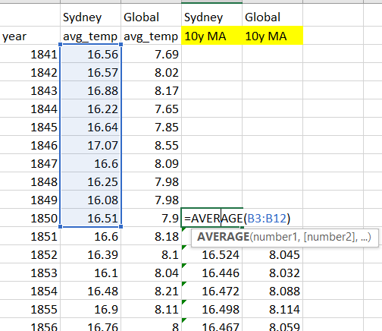

Since this is a simple data set with only two variables (i.e: Sydney and Global average temperature), a line chart was chosen for data visualization for its simplicity.

Key considerations for choosing the line-chart:

* It is should be something that I am most familiar with.
* It should be suitable for trend analysis over a period of time

Line chart is something that I have been too familiar with ever since high school. A bar chart would be another familiar one but it is not suitable given the large number of years. Moreover, for trend analysis, there is nothing better than a simple line chart.

1. **Findings**

Overall, Sydney temperature is consistently higher than the global temperature and the temperature difference between them appears to remain unchanged across the period. Both Sydney and global temperature have an upward trend in the change of temperature. Specifically, temperature has risen approximately 1.5 degree Celsius, from 16.5 to 18 in Sydney, and from 8 to 9.5 in global temperature.

Both have almost the same upward movement from year 1970 onwards although their movements were slightly different initially. In particular, global temperature appears to remain relatively constant from 1850 to 1913 until it had a steady increase from there onwards. On the other hand, Sydney’s figures had a slight increase from 1850 to 1880 but it stayed almost unchanged for almost a century until 1970 where it began to rise up again. This might suggest that global temperature is starting to affect Sydney in recent decades.

Nevertheless, it should be noted that the differences discussed above is quite minimal and both lines look very similar to each other at first glance. To find out whether other city have the same trend, New York data has been added as shown below:

With New York added in, it can be seen that while it has more noticeable fluctuations compared to the other two, it also has similar upward trend like the global line especially from 1970. This leads to the question whether global temperature actually affects city temperature. In order to answer this query, Excel function **CORREL** was used to calculate the correlation coefficient between the two variables as shown below. Both cities have a correlation of 0.9 against global data, indicating a strong positive relationship between global and city temperature.

|  |  |
| --- | --- |
| **Sydney vs Global** | 0.900258 |
| **New York vs Global** | 0.921907 |

In conclusion, our findings suggest that the earth is getting hotter over the period of nearly two centuries and the rise in global average temperature will also lead to the rise of city’s temperature, which is Sydney city in this study.